CAPTION
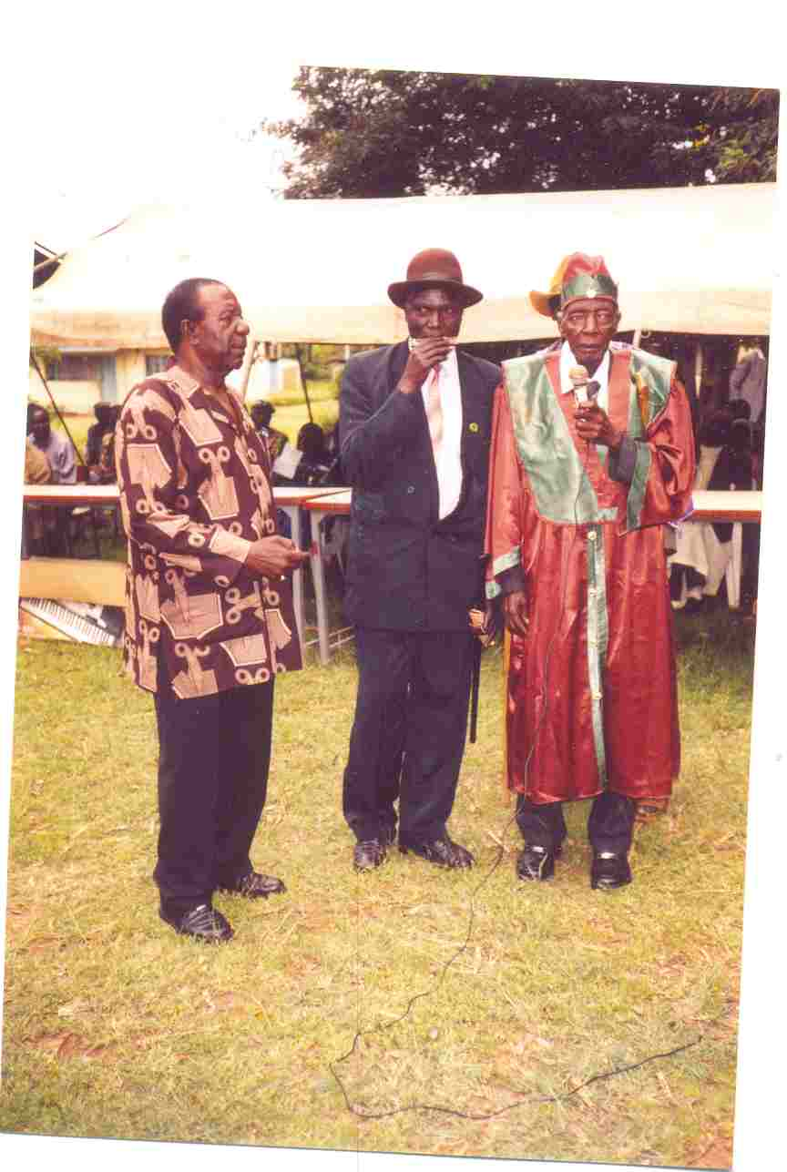

1. The KER of KANO Mzee Oselu Nyalick is seen with KER of Kabondo Aroko Mwage during his installation ceremony held at Otieno Oyoo Secondary School, Rabuor. Also in the picture is Mzee Walter Kitoto Adel the chairman of LEDEC

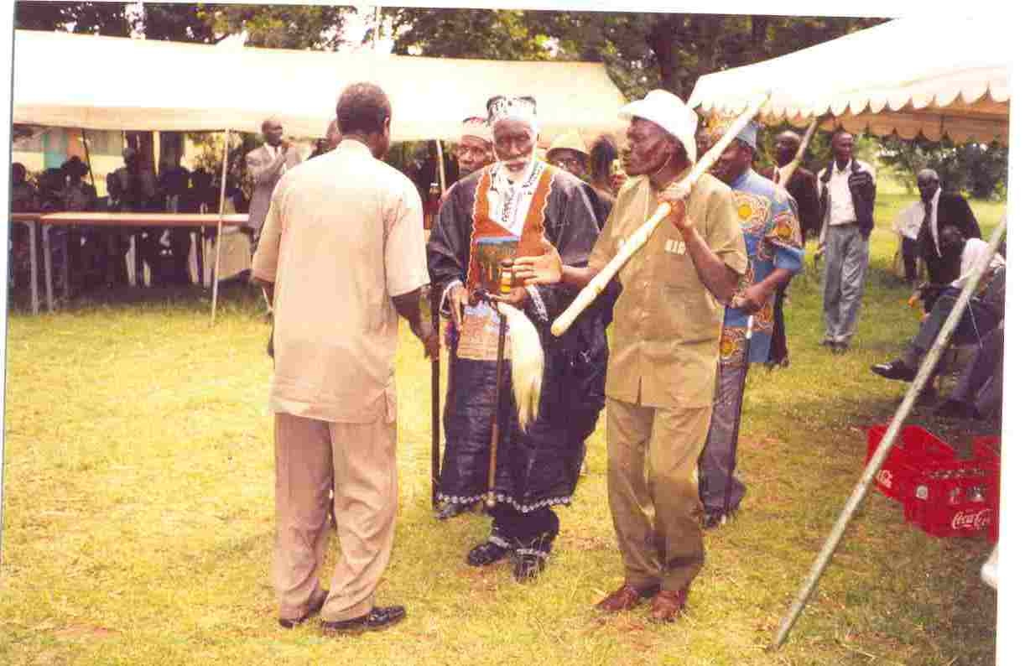

2. Adel with Luo Musicians

